# Operating System Lab_05

22CST 蒋云翔 2022102330

## Task1：

### Idea：

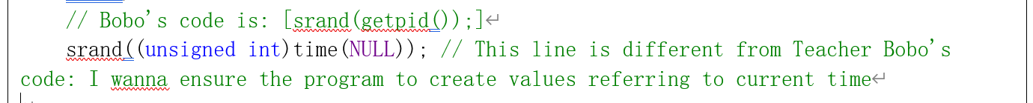

**The overall design idea of this program：**

* **Thread Creation**: Create a specified number of producer and consumer threads.
* **Data Sharing**: Define a shared buffer where producers can add data and consumers can remove data.
* **Synchronization Mechanism**: Use mutexes and condition variables for thread synchronization.

**The key points of this program and the key ideas to solve this problem:**

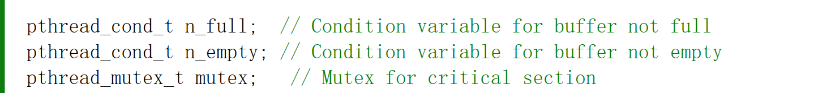



**1. Mutex (Mutual Exclusion)**

* **Purpose**: Protect access to shared resources (buffer) to prevent inconsistencies due to simultaneous access by multiple threads.
* **Implementation**: Use pthread_mutex_t to initialize a mutex and pthread_mutex_lock and pthread_mutex_unlock to lock and unlock the buffer access.

**2. Condition Variables**

* **Purpose**: Control the execution timing of producers and consumers, making producers wait when the buffer is full and consumers wait when the buffer is empty.
* **Implementation**: Use pthread_cond_t to initialize condition variables and combine them with mutexes using pthread_cond_wait and pthread_cond_signal for waiting and signaling mechanisms.

**3. Buffer Management**

* **Data Structure**: Design a fixed-size array as the buffer.
* **Index Management**: Use indices (e.g., in_index and out_index) to track where producers can add data and where consumers can remove data.

**4. Thread Creation and Synchronization**

* **Thread Identification**: Assign a unique identifier (ID) to each thread and pass it to the thread function.
* **Thread Functions**: Write pro_route and con_route functions to implement the behaviors of producers and consumers, respectively.

## Code structure

|  |
| --- |
| #include <stdio.h>  #include <stdlib.h>  #include <unistd.h>  #include <pthread.h>  #include <string.h>  #define PRO_NUM 3 // Number of producer threads  #define CON_NUM 2 // Number of consumer threads  #define BUFFER_SIZE 3 // Size of the buffer (Ps:can be changed!!!To simulate Bobo's expected execution, I set 3 here!!!)  pthread_cond_t n_full; // Condition variable for buffer not full  pthread_cond_t n_empty; // Condition variable for buffer not empty  pthread_mutex_t mutex; // Mutex for critical section  int buffer[BUFFER_SIZE];  int in_index = 0; // Index to insert into the buffer  int out_index = 0; // Index to remove from the buffer  int g_num = 0; // Number of products in the buffer  // Producer thread function  void* pro_route(void* arg) {  int id = *((int*)arg);  while (1) {  pthread_mutex_lock(&mutex);  while (g_num == BUFFER_SIZE) {  printf("Producer thread %d must wait.\n", id);  pthread_cond_wait(&n_empty, &mutex); // Buffer is full, wait  }  // Produce an item  int item = rand() % 100 + 1; // Random item to produce  buffer[in_index] = item;  in_index = (in_index + 1) % BUFFER_SIZE;  g_num++;  printf("Producer thread %d now produces\n", id);  printf("The number of products produced %d\n", g_num);  pthread_cond_signal(&n_full); // Signal that buffer is not full  pthread_mutex_unlock(&mutex);  // No need to free(arg) here, as we are using a loop  sleep(1); // Simulate time taken to produce an item  }  return NULL;  }  // Consumer thread function  void* con_route(void* arg) {  int id = *((int*)arg);  while (1) {  pthread_mutex_lock(&mutex);  while (g_num == 0) {  printf("Consumer thread %d must wait.\n", id);  pthread_cond_wait(&n_full, &mutex); // Buffer is empty, wait  }  // Consume an item  int item = buffer[out_index];  out_index = (out_index + 1) % BUFFER_SIZE;  g_num--;  printf("The consumer thread %d consumes product %d\n", id, item);  printf("The consumer thread %d has finished consuming product\n", id);  pthread_cond_signal(&n_empty); // Signal that buffer is not full  pthread_mutex_unlock(&mutex);  sleep(1); // Simulate time taken to consume an item  }  return NULL;  }  int main() {  // Bobo's code is: [srand(getpid());]  srand((unsigned int)time(NULL)); // This line is different from Teacher Bobo's code: I wanna ensure the program to create values referring to current time  pthread_t tids[PRO_NUM + CON_NUM];  // Initialize mutex and condition variables  pthread_mutex_init(&mutex, NULL);  pthread_cond_init(&n_full, NULL);  pthread_cond_init(&n_empty, NULL);  // Create producer threads  for (int i = 0; i < PRO_NUM; ++i) {  int* p = (int*)malloc(sizeof(int));  *p = i;  pthread_create(&tids[i], NULL, pro_route, p);  }  // Create consumer threads  for (int i = 0; i < CON_NUM; ++i) {  int* p = (int*)malloc(sizeof(int));  *p = i;  pthread_create(&tids[i + PRO_NUM], NULL, con_route, p);  }  // Wait for all threads to finish (this will never happen in this loop)  for (int i = 0; i < PRO_NUM + CON_NUM; ++i) {  pthread_join(tids[i], NULL);  }  // Destroy mutex and condition variables  pthread_mutex_destroy(&mutex);  pthread_cond_destroy(&n_full);  pthread_cond_destroy(&n_empty);  return 0;  } |

## Execution results:

|  |
| --- |
| **Stop the program by ctrl+z** |